**Lab - Tracing a Route**

# Instructions

## Verifying Network Connectivity Using Ping

* + 1. Start the CyberOps Workstation VM. Log into the VM with the following credentials:
    2. Open a terminal window in the VM to ping a remote server, such as [www.cisco.com](http://www.cisco.com).

* + 1. The first output line displays the Fully Qualified Domain Name (FQDN) e2867.dsca.akamaiedge.net. This is followed by the IP address 184.24.123.103. Cisco hosts the same web content on different servers throughout the world (known as mirrors). Therefore, depending upon where you are geographically, the FQDN and the IP address will be different.

e2867.dsca.akamaiedge.net

4 packets transmitted, 4 received, 0% packet loss, time 3004ms

rtt min/avg/max/mdev = 32.777/33.205/33.883/0.445 ms

## Tracing a Route to a Remote Server Using Traceroute

* + 1. At the terminal prompt, type **traceroute** [**www.cisco.com**](http://www.cisco.com).

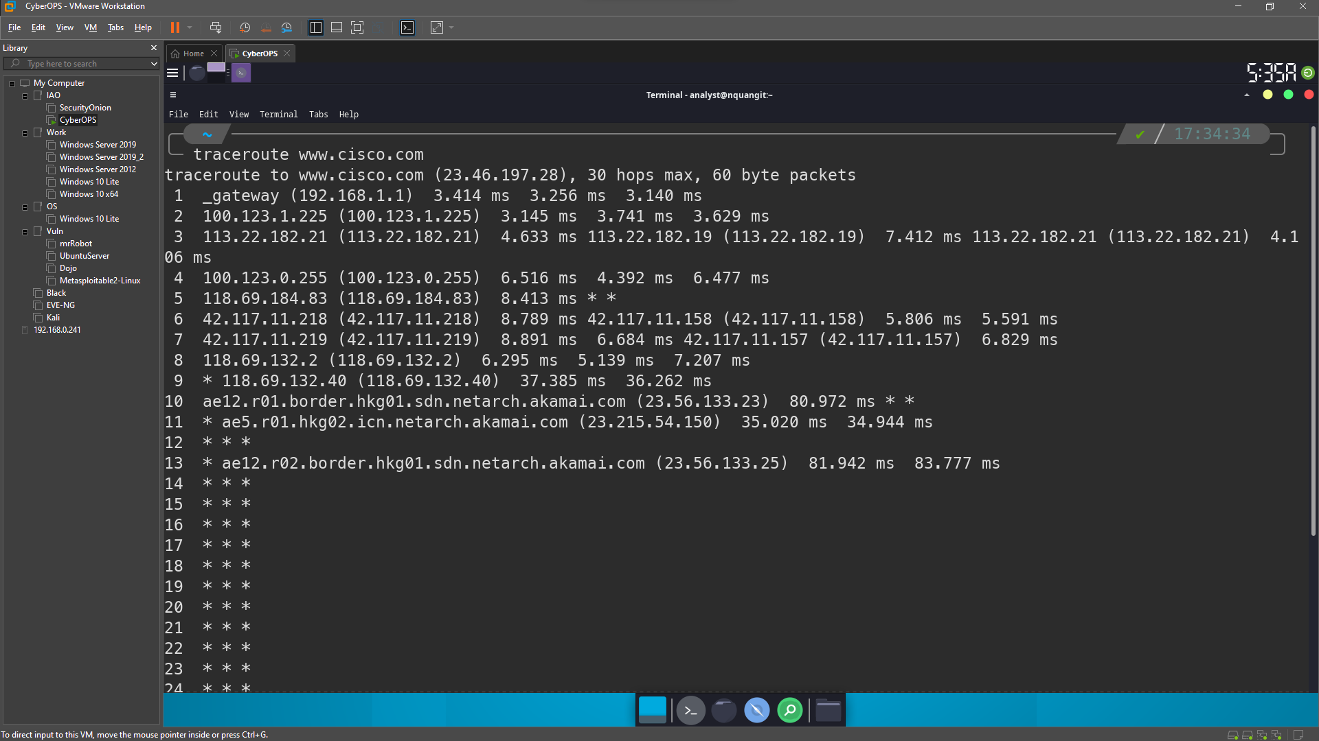

* + 1. If you would like to save the traceroute output to a text file for later review, use the right carat (>) and the desired filename to save the output in the present directory. In this example, the traceroute output is saved in the /home/analyst/cisco-traceroute.txt file.

* + 1. Perform and save the traceroute results for one of the following websites. These are the Regional Internet Registry (RIR) websites located in different parts of the world:

## Trace a Route to a Remote Server Using Web-Based Traceroute Tool

* + 1. Open a web browser in the VM and search for a visual traceroute tool that you can use in the web browser. Try going to the following website: <https://gsuite.tools/traceroute>
    2. Enter any website you wish. **Example: www.cisco.com** and press **Trace**.

Review the geographical locations of the responding hops. What did you observe regarding the path?

It doesn't always follow the shortest path from source to destination.

# Reflection Question

How is the traceroute different when going to www.cisco.com or other websites from the terminal (see Part 2) rather than from the online website? (Your results may vary depending upon where you are located geographically, and which ISP is providing connectivity to your school.)

The traceroute from the terminal is different than the one from the website. Domain names can be hosted on multiple mirrors worldwide. This is done so that access time to the website will be quick from anywhere in the world.